
Arab Academy for Science, Technology, and Maritime Transport
College of Engineering – Computer Engineering Dept.

Course | ECE3403 – Data Analytics & Optimization
Lecturer | Dr. Karma Fathalla – Dr. Doaa Shoieb
TAs | Yasmina Ayman – Hoda Osama – Marwan Nour

Sheet 2 - Problem Definition and Data Collection

Question 1:
Using a Public Dataset (Secondary Data) – Downloading & Loading Data
- Browse through text-based classification datasets at kaggle.com (Textual datasets).
- Download a well-structured dataset in CSV format.
- Save the dataset in the same folder as the Python script.
- Demonstrate how to fetch and load a dataset using pandas ( pd.read_csv()) and explore the dataset:
  - Display dataset preview using .head()and .tail()
  - Check basic info with .info()
  - Get the names of each column using .columns.tolist()
  - Get the data types for all columns using .dtypes
  - Check missing values with .isnull().sum()in each column.
  - Identify duplicates with .duplicated().sum()
  - Count unique values in each column with .nunique()
  - Generate statistics for numerical data using .describe()
  - Analyze skewness of numerical features with .skew()
  - Display counts for categorical columns (if exists) with .value_counts()

Question 2:
Web Scraping (Secondary Data) – Extracting Data from the Web
You are required to implement a python script that fetches web content from a news company website and scrapes the important headlines:
- Run pip install requests beautifulsoup4 to install requests and BeautifulSoup libraries.
- Define the desired URL in your code, (e.g.: https://www.bbc.com/news)
- Use requests library’s .get() to fetch the webpage
- Parse the retrieved HTML contents using BeautifulSoup(…, "html.parser") object.
- Extract headlines based on the website structure for headlines using .find_all( )
- Display the first 10 headlines by extracting human-readable text with .get_text()

Question 3:
Web Scraping (Secondary Data) – Extracting Data from the Web
Complete the python script below to collect job postings from a job listing website to analyze job demand for a specific role (e.g., "Data Analyst") which then outputs a structured dataset (CSV) containing job listings:
import requests
from bs4 import BeautifulSoup
import pandas as pd
URL = "https://wuzzuf.net/search/jobs/?q=data%20analyst&a=hpb"
response = requests.get(#..............)
if response.status_code == #..............:
soup = BeautifulSoup(#.............., "html.parser")
job_list = []
for job_card in soup.find_all("div", class_="css-1gatmva e1v1l3u10"):
job_title = job_card.find("a", class_="css-o171kl" ).text.strip() if job_card.find("a", class_="css-o171kl") else "N/A"
company = job_card.find("#..............", class_="#..............").text.strip() if job_card.find("#..............", class_="#..............") else "N/A"
location = job_card.find("span", class_="css-5wys0k").text.strip() if job_card.find("span", class_="css-5wys0k") else "N/A"
contract = job_card.find("#.........", class_="#..............").text.strip() if job_card.find("#............", class_="#..............") else "N/A"
job_site = job_card.find("#.............", class_="#..............").text.strip() if job_card.find("#..........", class_="#..............").text.strip() else "N/A"
# Store the extracted data
job_list.append({
#..............
})
# Convert the list into a DataFrame
df = pd.DataFrame(job_list)
df.to_csv("job_listings.csv", index=False) # Save the data to a CSV file
print("\nJob Listings Scraped Successfully!")
print(df.head())
else:
print("\nFailed to retrieve the webpage. Status Code:", response.status_code)

Question 4:
API Data Retrieval (Secondary data) – Fetching Data Programmatically
You are required to implement a python script that fetches data from an application programmable interface (API) that provides weather data of a city. Collect the hourly forecast for and convert it into a pandas dataframe.
- Define the URL to use WTTR.in API “https://wttr.in/Cairo?format=j1”
- Use requests library’s .get() to fetch the data programmatically in JSON format
- Use JSON parsing to handle API data using .json()
  - Hint! Visit http://json.parser.online.fr/ to view the parsed JSON string easily
- Extract Hourly forecast in a NumPy array where each row has:
  - “time”
  - “tempC”
  - “Humidity”
- Convert the NumPy array into a DataFrame
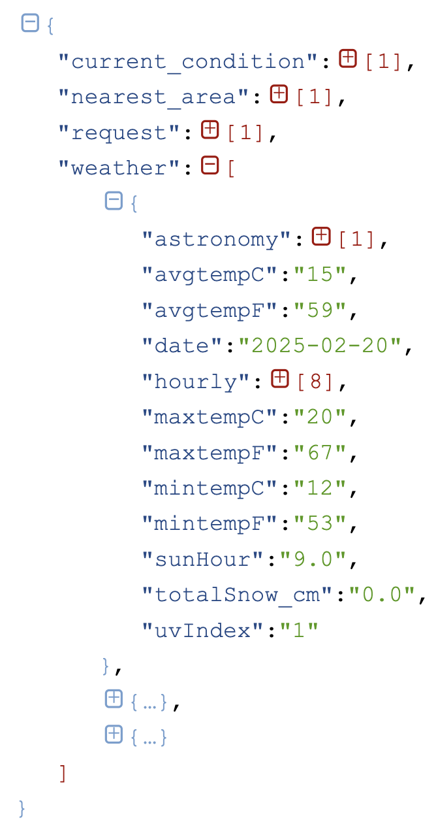
- Display the DataFrame

